# VA Mobile App Discovery: Card Sorting Report

## Background

As outlined in Phase One of the [VA Mobile App Discovery: UX Research Pla](https://docs.google.com/document/d/1x366wACqlyLjLWu9frsDzXM-f9BbkAUiK0Ur0ghWMw4/edit)n, we performed a card sorting activity to help determine what feature set Veterans most desire in a VA mobile application. This activity allowed us to determine what Veteran-centered direction we should go for [Phase Two](https://docs.google.com/document/d/1x366wACqlyLjLWu9frsDzXM-f9BbkAUiK0Ur0ghWMw4/edit#heading=h.b3k7aiymnjet): creating a testable prototype.

## Method: Card sorting

We used remote card sorting via Optimal Workshop to quickly understand how each Veteran would think about VA mobile features, prioritize and categorize them in a way that makes the most sense to them.The priorities we uncovered here will help shape our technical discovery and set the stage for usability style research in [Phase Two](https://docs.google.com/document/d/1x366wACqlyLjLWu9frsDzXM-f9BbkAUiK0Ur0ghWMw4/edit#heading=h.b3k7aiymnjet).

**Card sorting guide:** [VA Mobile App Discovery: Card sorting guide](https://docs.google.com/document/d/1fzgXrvUIsGaRv1frcWq2nc2cU5dG3ZAW-MJAM84gs5I/edit)

### Participant Demographics

There were a **total of 11 participants** (out of 24) that completed the study. In this section, we’ll break down some of the specific demographics we captured about the completed participants.

#### Screener

**7 participants were rejected by the screener question.**

All participants were asked if they were a Veteran who has used VA services through a website or application. If the answer was no, they were then sent to a message stating that they were not qualified to perform the activity.

#### Pre-study questions

We captured key demographics for the participating Veterans to help give us a better picture of these individuals. These questions were marked as optional.

**What branch (or branches) of the military have you served in? Please select all that apply.**

* 72.7% -- United States Army
* 18.2% -- Air Force
* 0% -- Navy
* 18.2% -- United States Marine Corps
* 0% -- Coast Guard

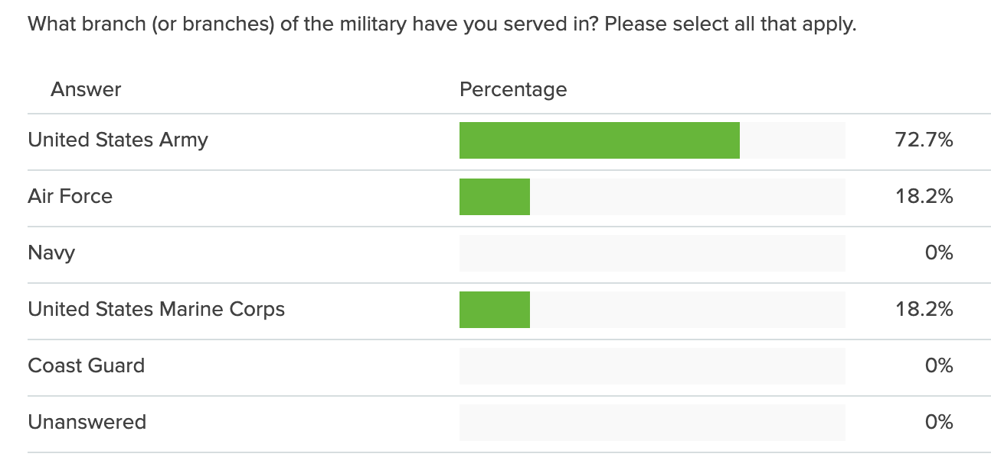

**In total, how long was your service throughout your military career?**

* 18.2% -- 2-4 years
* 18.2% -- 4-6 years
* 45.5% -- 6-10 years
* 18.2% -- More than 10 years

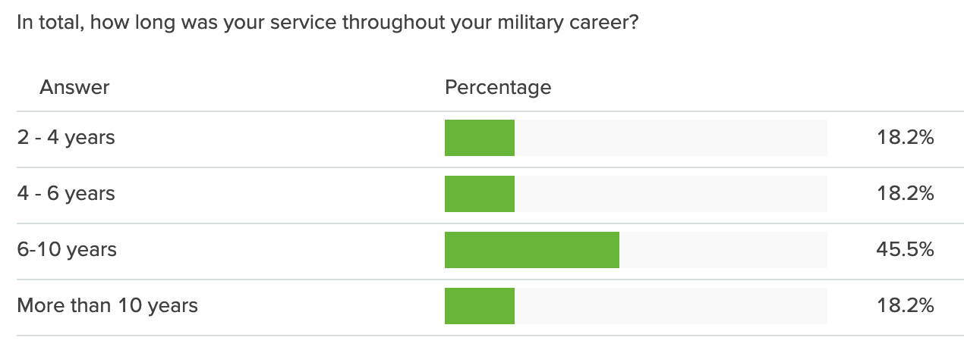

### Results

Below are the results from the card sorting activity and the feedback Veterans gave us on how they would categorize and prioritize features on a VA flagship mobile application. Each section shows the breakdown/number of participants and how they categorized each feature to let us know what features they would like to have.

#### What Veterans want

Below is a ranking of what Veterans told us that they want in a mobile application from VA, ranked in priority order. There were a few other cards listed as “Must have”, such as “Schedule and view healthcare appointments” and “View prescriptions and request refills” that we’d like to note, but they did not receive as high a ranking as other cards. We will be including these feature requests in our prototypes to capture the desire from Veterans.

**1. All participants would like to have the ability to request their military records on a VA mobile application.**

* 1 -- Must have
* 10 -- Nice to have

**2. Most participants would like to have the ability to change their address, phone number or email address on a VA mobile application.**

* 1 -- Must have
* 9 -- Nice to have
* 1 -- Not relevant

**3. Most participants would like to have the ability to upload documents for a claim using their phone’s camera on a VA mobile application.**

* 1 -- Must have
* 8 -- Nice to have
* 1 -- Not relevant

**4. Most participants would like to have the ability to get notifications about things like secure messages, appointments, claims status, etc on a VA mobile application.**

* 5 -- Must have
* 3 -- Nice to have
* 3 -- Not relevant

**5. Most participants would like to have the ability to get help in a crisis on a VA mobile application.**

* 4 -- Must have
* 4 -- Nice to have
* 3 -- Not relevant

#### What Veterans don’t want

**1. Most participants stated that they would not want to the ability to compare GI bill benefits by school on a VA mobile application**

* 0 -- Must have
* 3 -- Nice to have
* 8 -- Not relevant

**2. Most participants stated that they would not want the ability to sign in for an appointment on a VA mobile application.**

* 0 -- Must have
* 5 -- Nice to have
* 6 -- Not relevant

**3. Some participants stated that they would not want the ability to view payment history for a benefit on a VA mobile application.**

* 1 -- Must have
* 4 -- Nice to have
* 6 -- Not relevant

**Most participants stated that they would not want to add VA documents or cards (such as DD214) to your Apple Wallet or Android Pay**

* 1 -- Must have
* 4 -- Nice to have
* 6 -- Not relevant

### Recommendations

Below are a set of recommendations to inform Phase Two prototyping and usability testing. Using their mobile devices, all Veterans should have the ability to:

1. Request, access, view and/or download their most current military history (DD214).
2. Edit the name, phone number and email address associated with their VA services
3. Easily upload documents camera to attach missing and supportive evidence for upcoming or ongoing VA claims.
4. Receive notifications for things like secure messages, appointments and claims status
5. Easily be able to connect with the Veterans Crisis Line.